# Desk notes for local authority dashboard

# Notes on R Shiny

A Shiny application is a delivery vehicle for an R script. For an R shiny application there is a server (render) file and a UI (output) file. The Server.R file is a set of instructions that build the R components of your app. The Ui.R file is a description of your application’s User Interface (UI) - the web page that displays your application. The user interface works on a grid system. Both inputs and outputs go into the UI, inputs are things such as drop down menus, outputs are what you want to display eg a chart.

# Local authority dashboard for the attainment by 19 SFR

The latest version of all the files required can be accessed through the repository set up for us on Visual Studio Team Services (VSTS) (an alternative to using github) by Laura Selby here:

<https://disd-modernisation.visualstudio.com/_git/NEET_shiny_app/>

(Laura named it NEET_shiny_app but said she can change this easily when we want to rename to something more relevant for the attainment SFR). You need to be given access to this area. To do this follow Laura’s instructions below:

* First, set up an account to be able to use VSTS, here - <https://www.visualstudio.com/team-services/>
* Then download the git software, if you don’t have google chrome you will need to install this first because for some reason the download doesn’t work via internet explorer.  <https://git-for-windows.github.io/>
* Then Laura granted access to the [https://disd-modernisation.visualstudio.com/_git/NEET_shiny_app](https://disd-modernisation.visualstudio.com/_git/NEET_shiny_app/branches) repository. Though here we reached the maximum number of members for the disd-modernisation group so Sally couldn’t see or interact with the code. Laura has emailed Paul to ask if there’s a way for us to expand the number of members in this group, if this is possible then she can just add Sally and Julian to the group again, if not she’ll move the repository to Julian’s group.
* In your file explorer go to your C:\ drive and search for a .gitconfig file, here you need to set proxy settings so your local version of the repository can connect to the VSTS version. Anneka’s version is set up so it all works so should be able to send what you need.
* On your desktop create an ‘R projects folder’ which you can use to store all of your local versions of each repository you work on.
* In VSTS click on the code tab so you can see the list of files that make up the app, in the top right there is a clone button. Click it and generate your git credentials (basically create a password).

Then click the copy icon to copy the https link to your clipboard

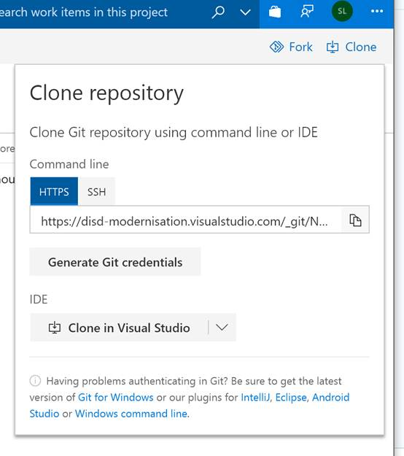

* In your new ‘R projects’ folder right click and you should see a ‘git bash here’ option. This is how you clone the repository. It should open a command line window where you need to type –

**git clone [paste https link]**

It should then ask you to add your git credentials (which you created above).

* Now you should have a folder in your R projects folder called ‘Neet_shiny_app’. And if you click the project file it will open everything in R and you should now have a git window in the top right of the console. Note you may have to select the ‘NEET_shiny_app’ project first in the top right corner of the R window. You can then select the branch you want to work from and commit, push and pull to the repository.

The files:

# Data

Within the data folder there are several files named England_LA_2016. These are all files required for the map and you don’t need to change.

The csv file within here is the local authority underlying data. The new data will need to be in the same format as this.

**R is case sensitive.** Please ensure all column headings and categories are the same as in the current version of the underlying data that feeds into the app. In particular, currently in the underlying data we have ‘ALL’ or ‘a.ALL’, if you change this to lower case ‘All’ then we’ll need to update the codefile_shiny file wherever it includes this in the filters.

Important! Please ensure the underlying data is ordered by ‘cohort_19_in’ otherwise plots don’t display correctly as they seem to be drawn in the order the data appears in the csv.

Once you save your new csv underlying data file in this folder (it can be named anything), you can move the old underlying data into the old versions folder to keep the data folder tidy.

# codefile_shiny

I created this code file first – it contains code that feeds into the Server file. **Note** the first time that you use R you’ll need to install certain packages. To do this go to Tools at the top of the R window and Install Packages… Type the following packages in the box:

*leaflet geojsonio rgdal sp data.table RColorBrewer raster pander tidyverse shinycssloaders plotly DT ggalt magrittr*

You’ll only need to do this once.

The code is split into 5 sections.

1. Load packages – this loads the packages required to run our application.
2. Creating useful functions – here we create a function to say increased/decreased when we include yearly changes in the text on our application. We also set the latest year as a function which avoids us having to update lots of the code when new data is available.
3. Load the data required – here we point to the underlying data csv file we’ve created as specified above contained within the ‘data’ folder.
4. Overview tab – this code defines the national charts we include on the front page of the application.
5. All the code required for the FSM tab – plots, tables, rate references for the summary text.
6. All the code required for the SEN tab – plots, tables, rate references for the summary text.
7. Data downloads – code to create the data downloads for FSM and SEN.
8. Map – code defining the map.

**You don’t need to run this code at all, just change the latest year reference in section 2 and the underlying data reference in section 3, then save.**

# server

This code defines the outputs in the application using the code file created above.

Nothing should need updating in here as all the summary text (LA, region and National) use the latest_year function defined in section 2 of the codefile_shiny above. However if you want to change any of the hard coded summary text that appears in the application then that should be changed in here.

# ui

This code defines each of the tabs in the application. Not much will need updating in here, just the text and hyperlinks in the first Overview tab and final data and methods tab, and the year reference in the title of the map tab. Once updated save the file and then click run app at the top (this icon only appears when you’re in the ui or server file, you can’t run the application from the codefile):

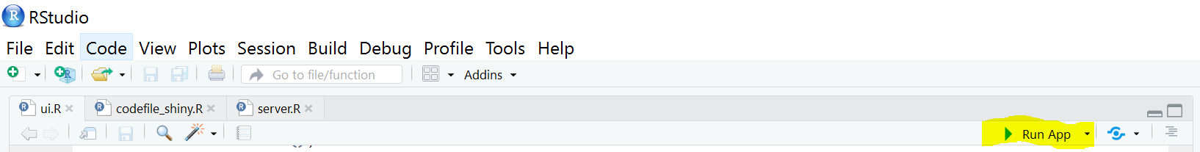

**Useful info**

== for equal to in when selecting within variables e.g. in the filter in section 4 of the code file

!= for not equal to

# to comment out

To comment out a block of code, highlight then control+shift+c

Can run the app from either the server or the ui (user interface) file

SM- In the UI you define the display i.e. say what you want the user to do e.g. Pick a LA

For example you are defining select2 as la_name in the la_plot_data (as defined in codefile) which is then referenced in the server file as a type of output to be displayed i.e. ’T1 chart’.